Main Page

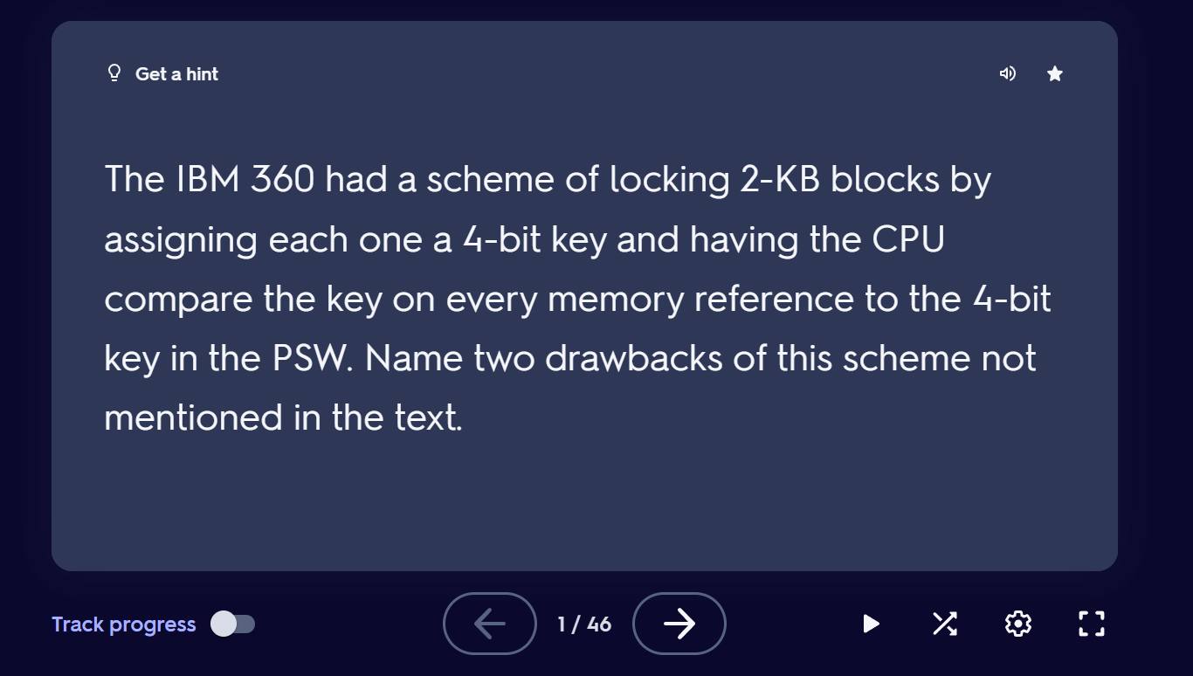

<https://quizlet.com/338444177/chapter-3-memory-management-flash-cards/?funnelUUID=3966d142-1e29-41b0-b1eb-b425ceab4c2b>

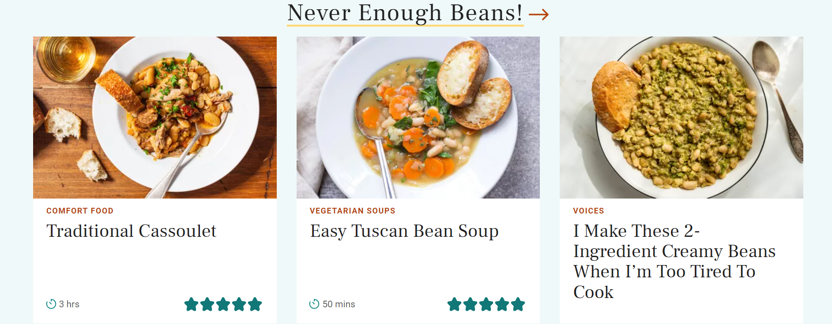

https://thegoodocs.com/freebies/recipe-templates/

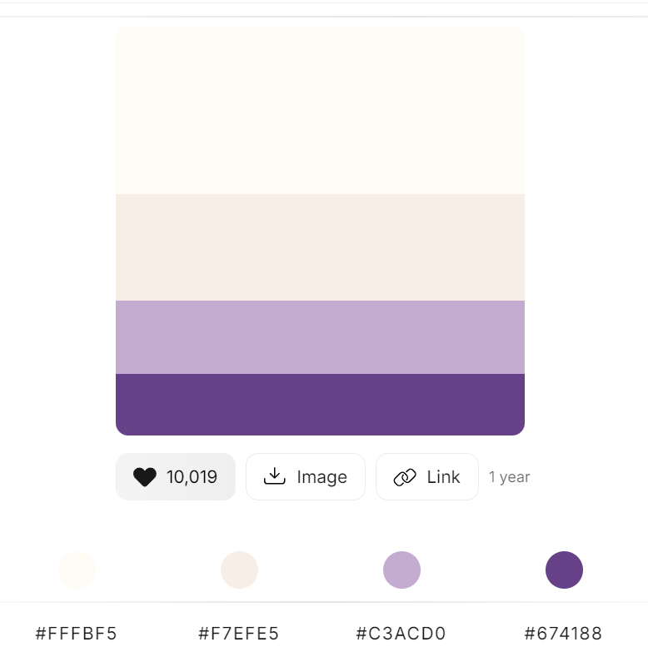

<https://colorhunt.co/palette/fffbf5f7efe5c3acd0674188>

Personal Recipe Cateloger



Button to add a recipe to

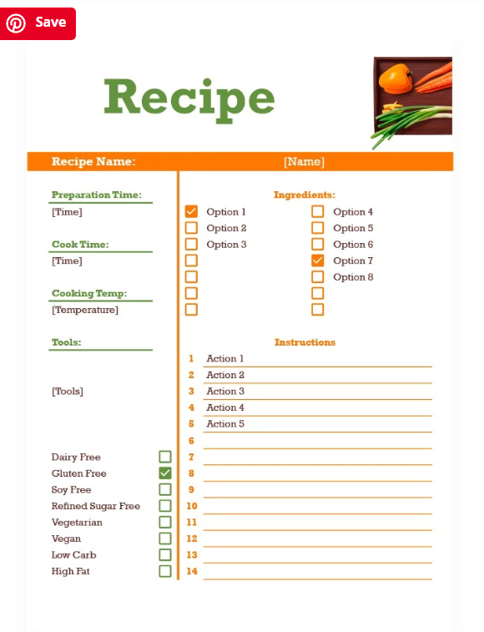

<https://thegoodocs.com/recipe-templates/orange-and-green-recipe.php>

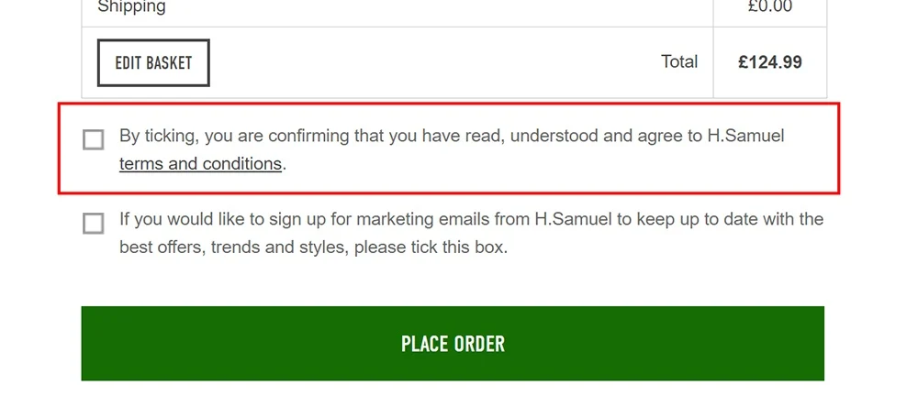

https://www.termsfeed.com/blog/i-agree-checkbox/